**How To Document:**

Please run “git lfs install” as model file is larger than 100MB

1. **Setup in Local:**

Install Python

Open code in VS Code

Go to View -> Command Palette

Click on create environment  
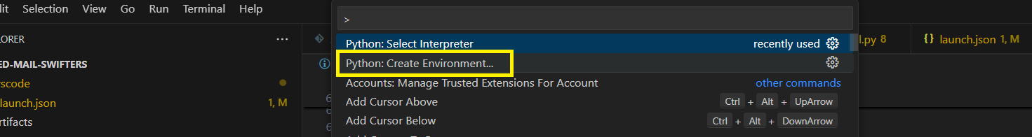

Select Venv

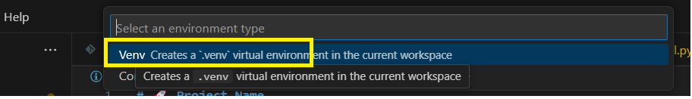

Choose interpreter  
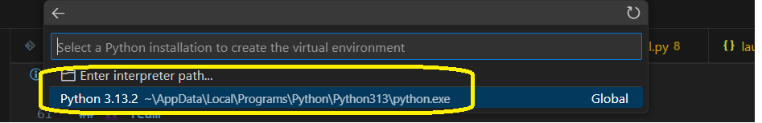

Choose requirements file

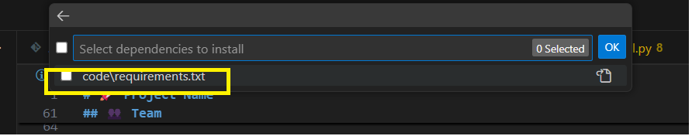

And click OK, it takes a while to create virtual environment  
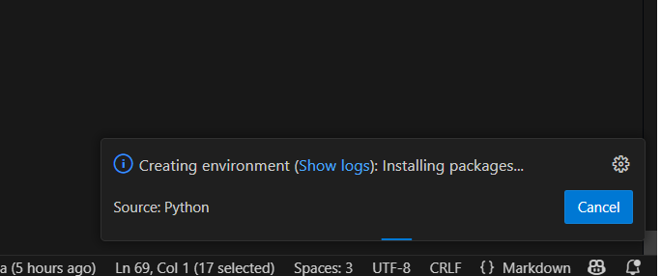

Once done we can see .venv folder

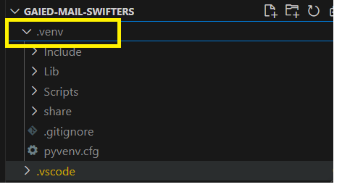

Creating this virtual environment is optional, if not created it will get the python packages from system, we may get into version issues.

Update this path as per local machine in .vscode -> launch.json

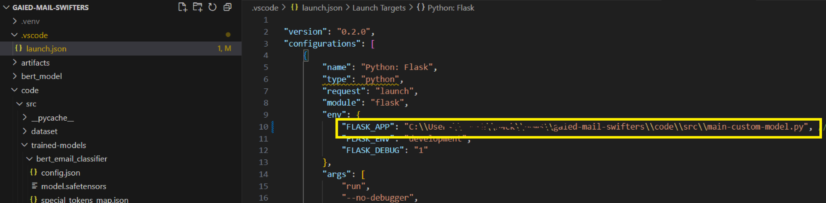

1. **Classification API**

Open “main-custom-model.py” file under “code\src\main-custom-model.py”

From VS Code -> Run -> Choose either Run Without Debugging or Start Debugging, To debug

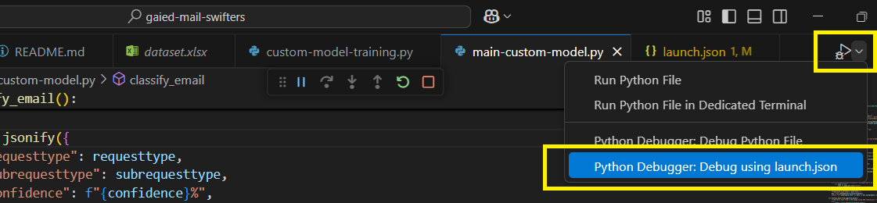

From command palette choose flask if debugging

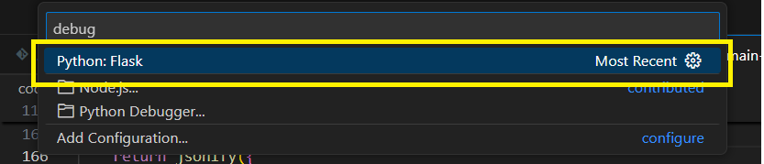

1. **Postman Sample Request:**

We can take the running host url from VS Code terminal

1. **UI Part**

Go to -> code\src\home.html to open home.html in browser

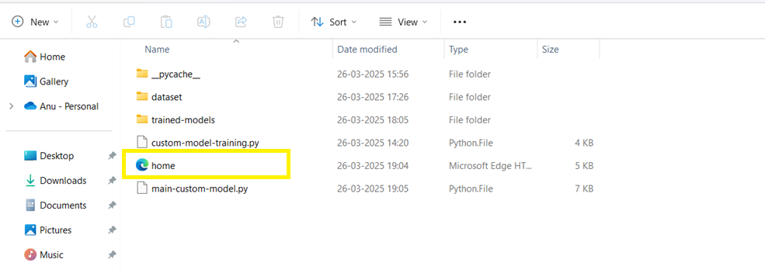

In browser:

Choose .eml/.docx/.pdf/.jpg file and click on upload

1. **[Optional if we change dataset] Model training:**

We have used BERT Transformer model and trained that using dataset under “code\src\dataset\dataset.xlsx”

To train model open “code\src\custom-model-training.py” file and in VS Code go to Run -> either Start Debugging or Run Without Debugging, if debugging option is chosen then use this option

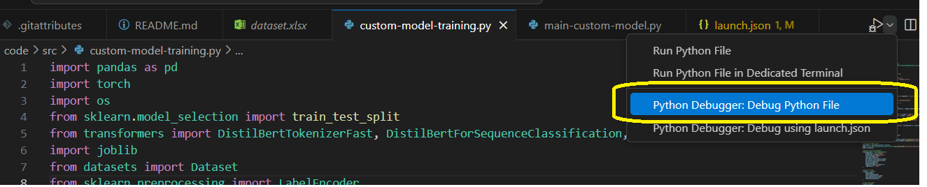

When execution is done it will save trained model files under “code\src\trained-models” path